|  |  |
| --- | --- |
| EGC_Black | Student Name \_\_\_\_\_\_\_\_\_\_\_\_\_\_\_\_\_\_\_\_\_\_\_\_\_\_\_\_\_    **Eastern Goldfields College**  Mathematics Essentials 2015  Application 3 – Leavers  1 |

**TIME:** 50 min  **TOTAL MARKS**: 47

This practical application is worth 8% of your course mark.  
 **Equipment needed**: calculator, notes, ruler and laminated maps.

Soon you will be finishing school and you want to celebrate this event. In November this year, students celebrate the end of school life by participating in ‘Leavers’, also known as ‘Schoolies’. There are three possible options available to you, they are:

* travel to Hong Kong in China;
* travel to ‘Schoolies’ on the Gold Coast in Queensland; or
* use a ‘mystery’ aeroplane ticket that takes you to an unknown location.

In this application, you are required to determine travel distances, time and packing requirements to travel to these and other destinations around the world.

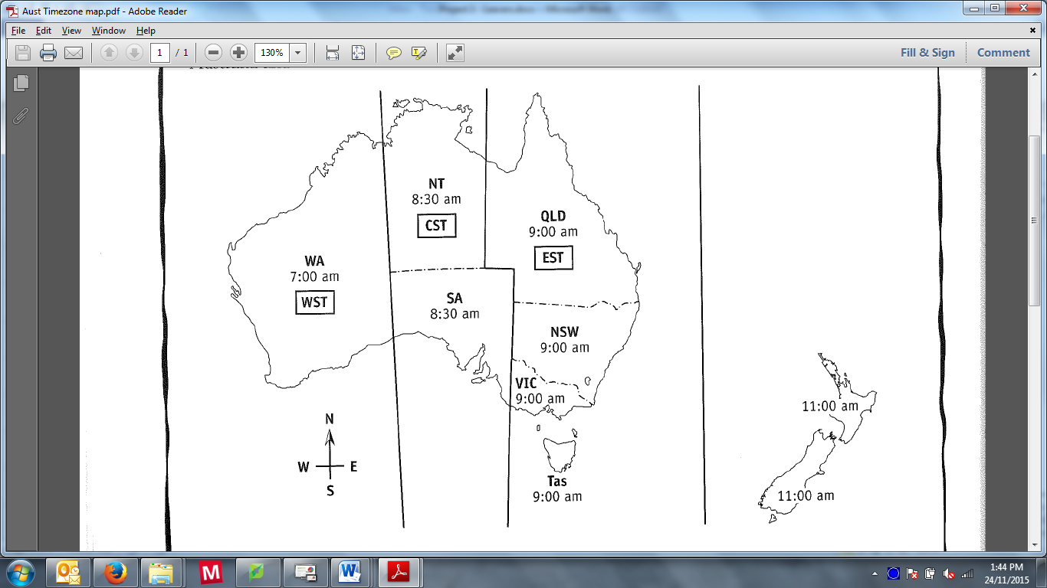

Australian Standard Time is divided into three sections:

* AEST – Australian Eastern Standard Time
* ACST – Australian Central Standard Time
* AWST – Australian Western Standard Time

Note: To move from west to east, add on the time difference. To move from east to west, subtract the time difference.

**Question 1 (7 Marks: 4, 3)**

1. Complete the table below to show the local time in each region.

|  |  |  |  |
| --- | --- | --- | --- |
| **AWST** | **ACST** | **AEST** | **New Zealand  Standard Time** |
| 6:15 am |  |  |  |
|  | 2:30 pm |  |  |
|  |  | 1:45 pm |  |
|  |  |  | 11:10 am |

1. Leavers is held in late November when some Australian states will be using Daylight Savings Time. Complete the table below for Australian Central Daylight Savings Time (ACDT) and Australian Eastern Daylight Savings Time (AEDT).

|  |  |  |
| --- | --- | --- |
| **AWST** | **ACDT** | **AEDT** |
| 4.30 am |  |  |
|  | 3.45 pm |  |
|  |  | 10:00 pm |

**Question 2 (3 Marks)**

Use the maps provided to answer this question.

To the nearest 5 degrees, determine the approximate global position using latitude and longitude of each of the following locations:

* Perth \_\_\_\_\_\_\_\_\_\_\_\_\_\_\_\_\_\_\_\_\_\_\_\_\_\_
* Hong Kong \_\_\_\_\_\_\_\_\_\_\_\_\_\_\_\_\_\_\_\_\_\_\_\_\_\_
* Gold Coast \_\_\_\_\_\_\_\_\_\_\_\_\_\_\_\_\_\_\_\_\_\_\_\_\_

**Question 3 (6 Marks: 3, 3)**

1. Use the arc length formula (and your answers from question 2) to calculate the approximate global distance between Perth and Hong Kong. Show your working.

1. Using the scale and map of Australia provided, estimate the distance, as the crow flies, between Perth and Gold Coast. Show your working.

**Question 4 (4 Marks: 2, 1, 1)**

Using your results from Question 2 and the general rule that every 15˚ east advances the time by one hour, and every 15˚ west decreases the time by one hour, estimate the number of hours ahead, or behind, Greenwich Mean Time (also known as UTC) it will be in the following locations?

1. Gold Coast
2. Hong Kong
3. Perth

**Question 5 (7 Marks: 3, 2, 2)**

1. The flight from Perth to Hong Kong takes approximately 8 hours. Using your results for Question 4, what time would you arrive in Hong Kong if you left Perth at 9:00 am, in:
2. Local, Hong Kong, time? \_\_\_\_\_\_\_\_\_\_\_\_\_\_\_\_\_\_\_
3. Which time zone is this? \_\_\_\_\_\_\_\_\_\_\_\_\_\_\_\_\_\_\_
4. The flight from Perth to Gold Coast takes approximately 5 hours, what time would you arrive in Gold Coast if you left Perth at 9:00 am, in
5. AWST time? \_\_\_\_\_\_\_\_\_\_\_\_\_\_\_\_\_\_\_
6. Local, Queensland time? \_\_\_\_\_\_\_\_\_\_\_\_\_\_\_\_\_\_\_
7. The Gold Coast is in Queensland; however this city has grown so large that it has merged with Tweed Heads, similar to Kalgoorlie merging with Boulder. Tweed Heads is the northern most city of New South Wales. New South Wales has daylight savings during ‘Schoolies’ whereas Queensland does not.

If you were to walk along the Coolangatta beach on the Gold Coast at 3:30 pm and enter the beach at Tweed Heads 5 minutes later, what time would it be when you step onto the Tweed Heads beach?

**Question 6 (4 Marks)**

During your planning for Leavers you have realised you have relatives in both Hong Kong and the Gold Coast so you have decided to see if you could stay with either of them to save money. To save time you decide to conference call both relatives at the same time. Your Uncle lives in Hong Kong and works 8:00am-5:00pm local time whilst your Cousin lives on the Gold Coast and works split shifts of 5:00pm-7:00pm and 9:00pm to Midnight. What would be the best time to call? Justify your answer

**Question 7 (9 Marks: 1, 2, 2, 4)**

You have also been given a mystery ticket to an unknown location. The location has the global coordinates of 34.00°N 118.17°W. Use the atlas provided to answer the following:

1. What city can be found at theses coordinates?
2. Using the longitude of the mystery city, estimate how many hours it will be ahead or behind
3. Greenwich Mean Time
4. Australian Western Standard Time (Perth)
5. Do the following direct flights cross the International Date Line?  
   1. Perth to Hong Kong Yes / No (circle)
   2. Perth to the mystery city Yes / No (circle)
6. A direct flight to the mystery city from Perth takes 20 hours. If your flight leaves Perth at 5:30pm on Monday the 28th on November, what will be the time and date of your arrival in the mystery city? Remember to take into account any changes due to the IDL.

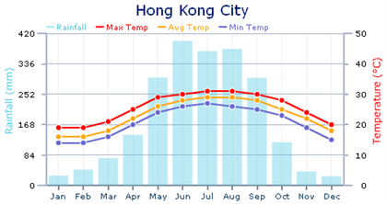**Question 8 (7 Marks: 2, 1, 4)**

Use the graphs on the right to assist in answer the following questions.

1. What information do these graphs provide?
2. What month of the year is ‘Leavers’?

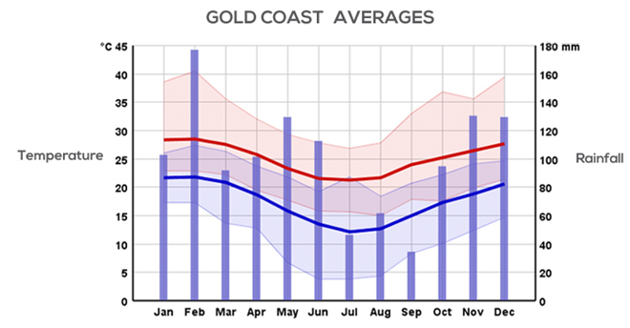

1. For each of the following ‘Leavers’ destination options list the items of clothing you would pack and why.   
   Hint: use the “What on Earth am I Wearing” image to assist with your list.

Hong Kong



Gold Coast